

JSON Debugger
15.12.2025
─
Sreekanth
Your Company
123 Your Street
Your City, ST 12345

Problem Statement
Developers often work with broken or malformed JSON coming from logs, API responses, or console output. Existing tools simply say “error” without explaining where or why. This wastes time and breaks debugging flow. My tool will validate, detect errors, explain issues, and fix JSON using AI.

Target Users
- Frontend developers
- Backend developers
- QA testers
- Students learning APIs
- API tool users (Postman/Insomnia)

MVP Features (Maximum 3)
- Validate JSON → return formatted JSON if valid
- Show error (line, column, explanation) if invalid
- AI Fix → returns corrected JSON + explanation

Non-Goals
- No login/signup
- No database
- No saved history
- No pricing
- No user accounts
- No fancy UI
- No mobile features

Success Criteria
My MVP is done when:
- Validation works for common JSON
- AI fix returns correct JSON 80% of time
- 3–5 devs can use it without confusion
- UI shows errors and fixes cleanly

User Flow

User pastes JSON into left editor
- User clicks Validate
  - If valid → formatted JSON on right
  - If invalid → error details shown
- User clicks Fix with AI
  - AI returns corrected JSON
  - Explanation displayed
- User can copy corrected JSON
This is small but makes implementation smoother.

UI design/wireframe
UI is intentionally minimal to reduce distraction. Only essential buttons and outputs are shown. Editor on left, results on right.
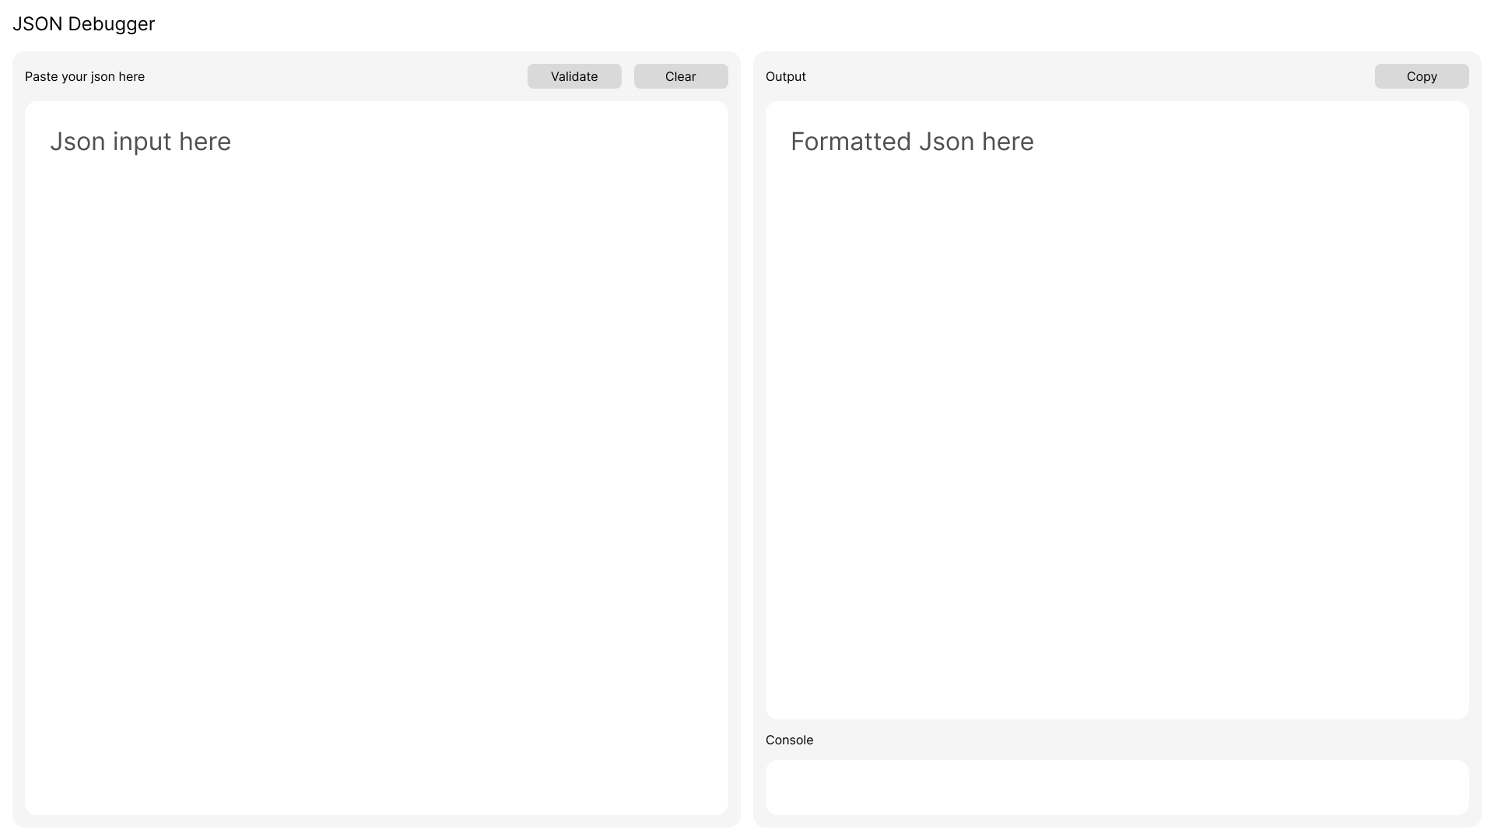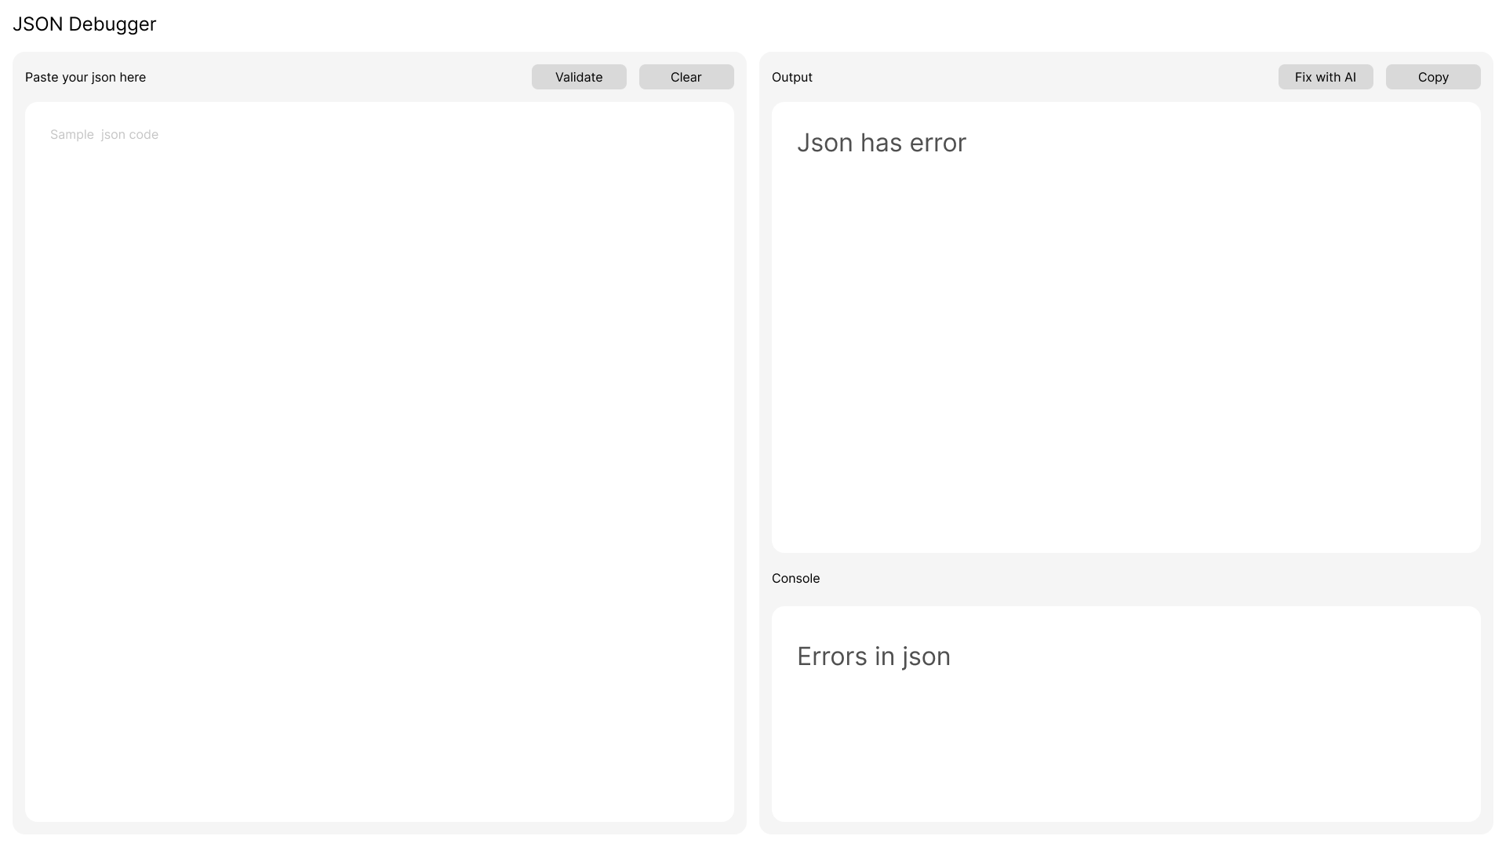
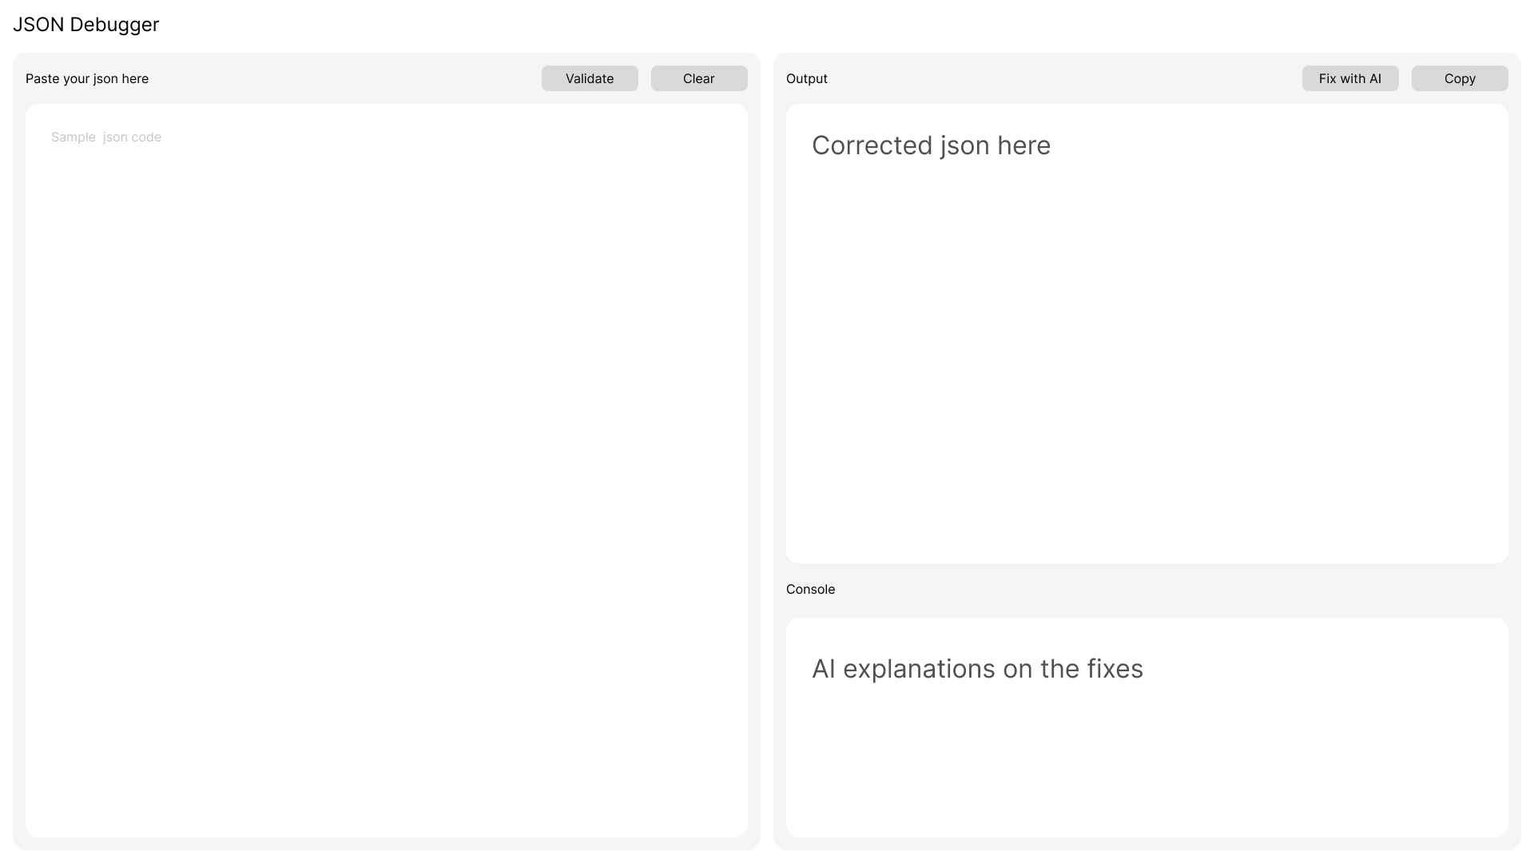

Error Handling Rules
- If JSON is invalid → show error panel only, do NOT attempt to format
- Always keep user input editable
- Highlight error line (phase-2 feature)

AI Rules
- AI must only correct structure, not change data
- Response must be only JSON (no explanation mixed inside)
- Explanation should be a separate field

Technical Scope
- Angular 20 + Tailwind + Primeng
- Node/Express backend
- No database (MVP)
- OpenAI/Gemini for JSON fixing
- Hosted on Vercel + Render

Testing Plan
- Test with 20 sets of valid JSON
- Test with 20 sets of invalid JSON
- Ensure error messages map to correct lines
- Ensure AI fixes at least 80% of common issues

